**PART 1**

1. 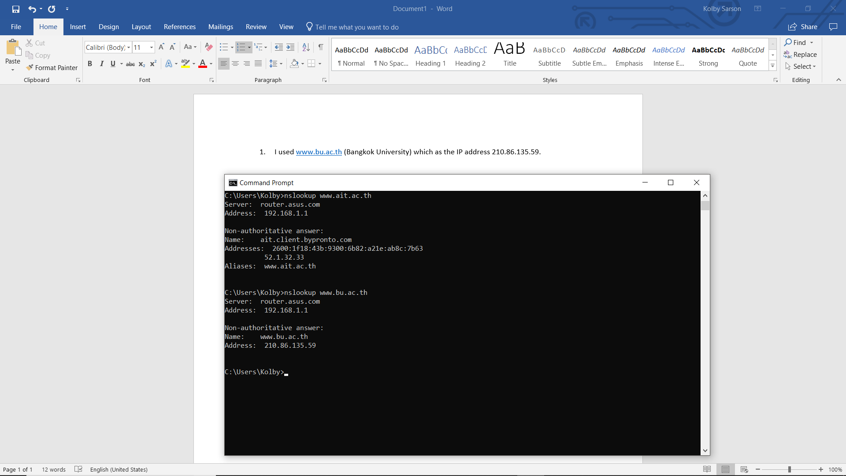 I used www.bu.ac.th (Bangkok University, Thailand) which has the IP address 210.86.135.59.
2. I used ox.ac.uk (Oxford University, UK) which has the IP address 192.168.1.1.

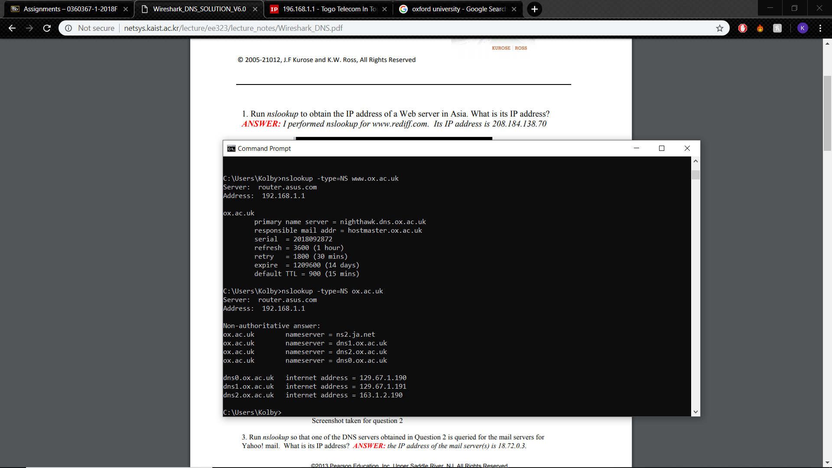

1. 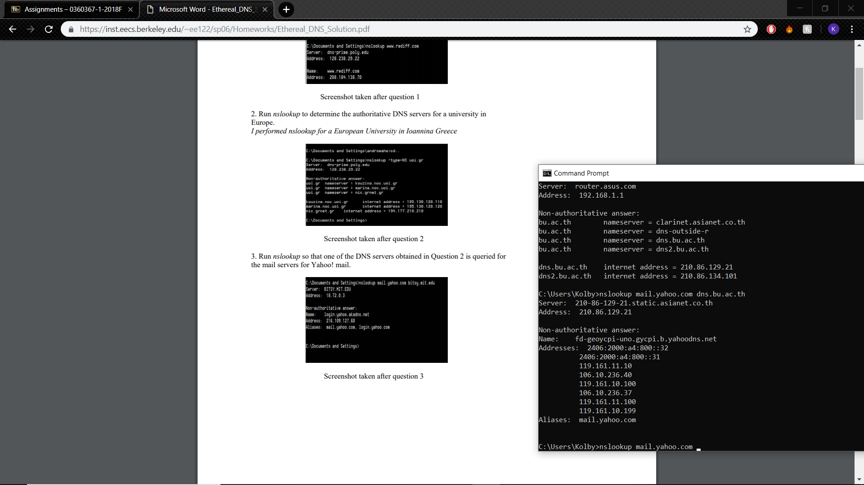I used dns.bu.ac.th (From part 1 server as part 2 server got DNS timeout) which has the address 210.86.129.21.

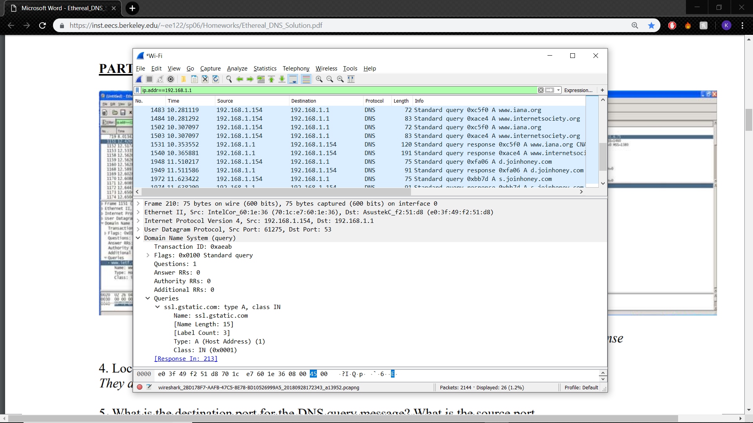**PART 2**

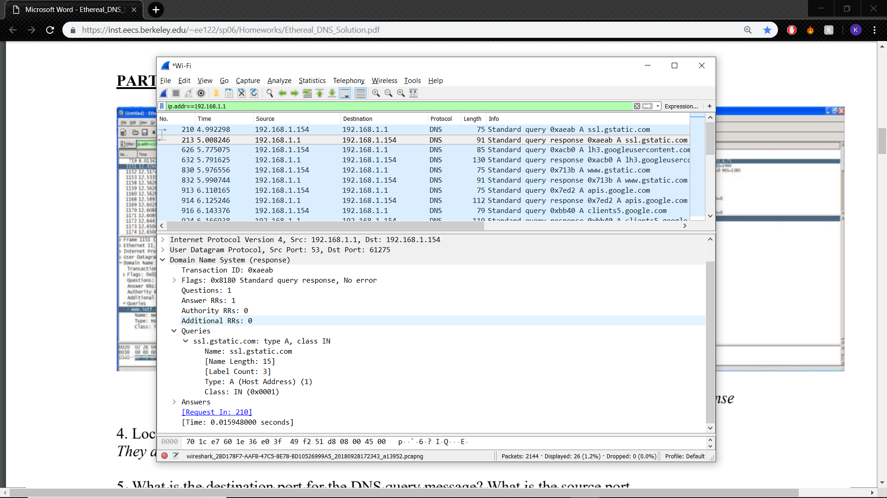

1. They are sent over UPD.
2. 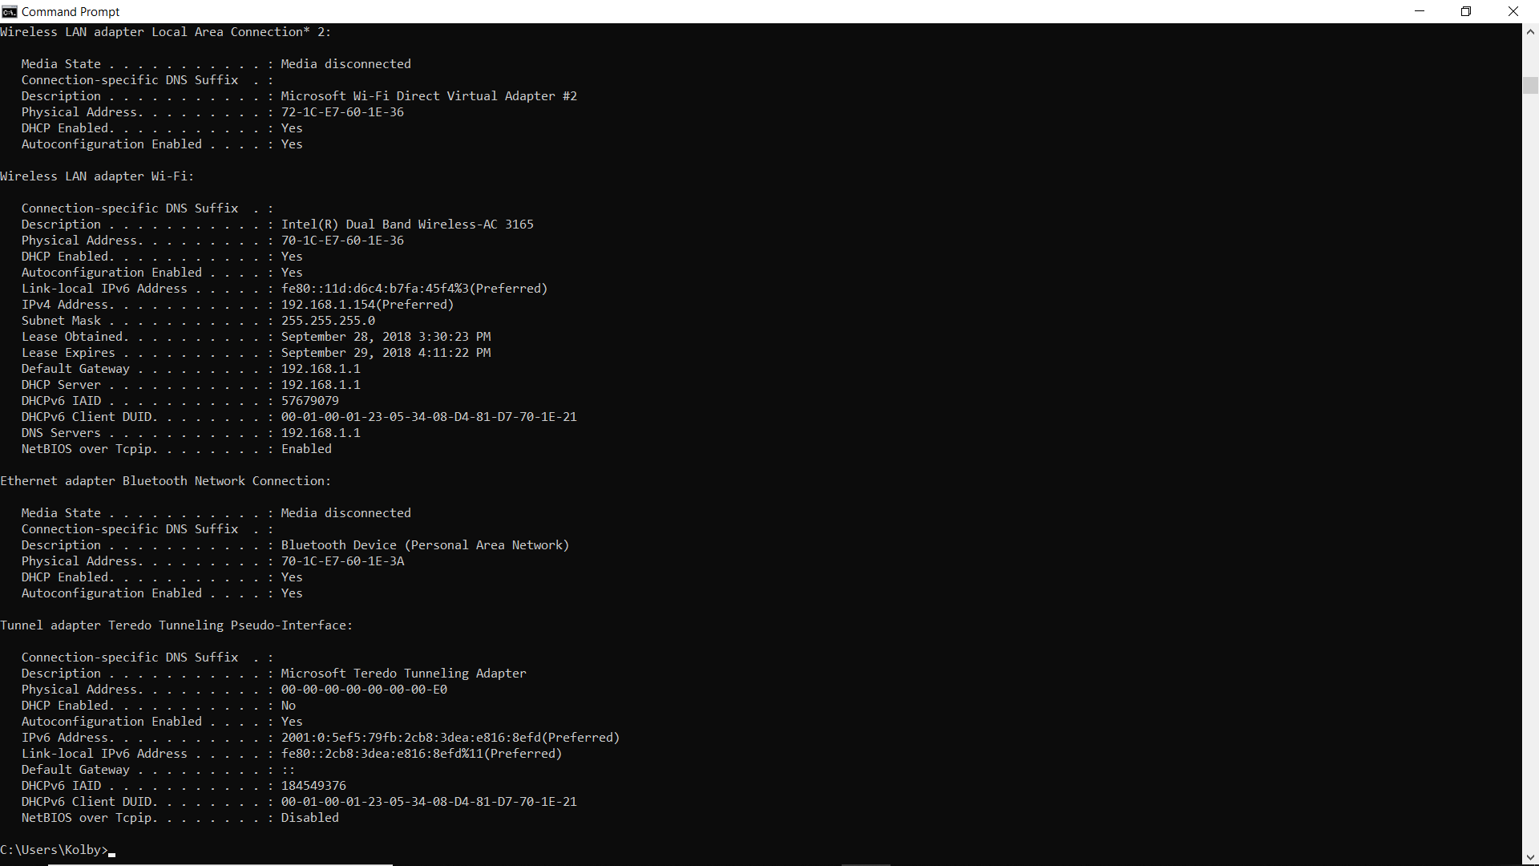The destination port for the DNS query message is 53 and the source port of the DNS response message is 53.
3. It’s sent to 192.168.1.154, which corresponds to the IPv4 address.
4. The query is type A and does not contain any answers.
5. 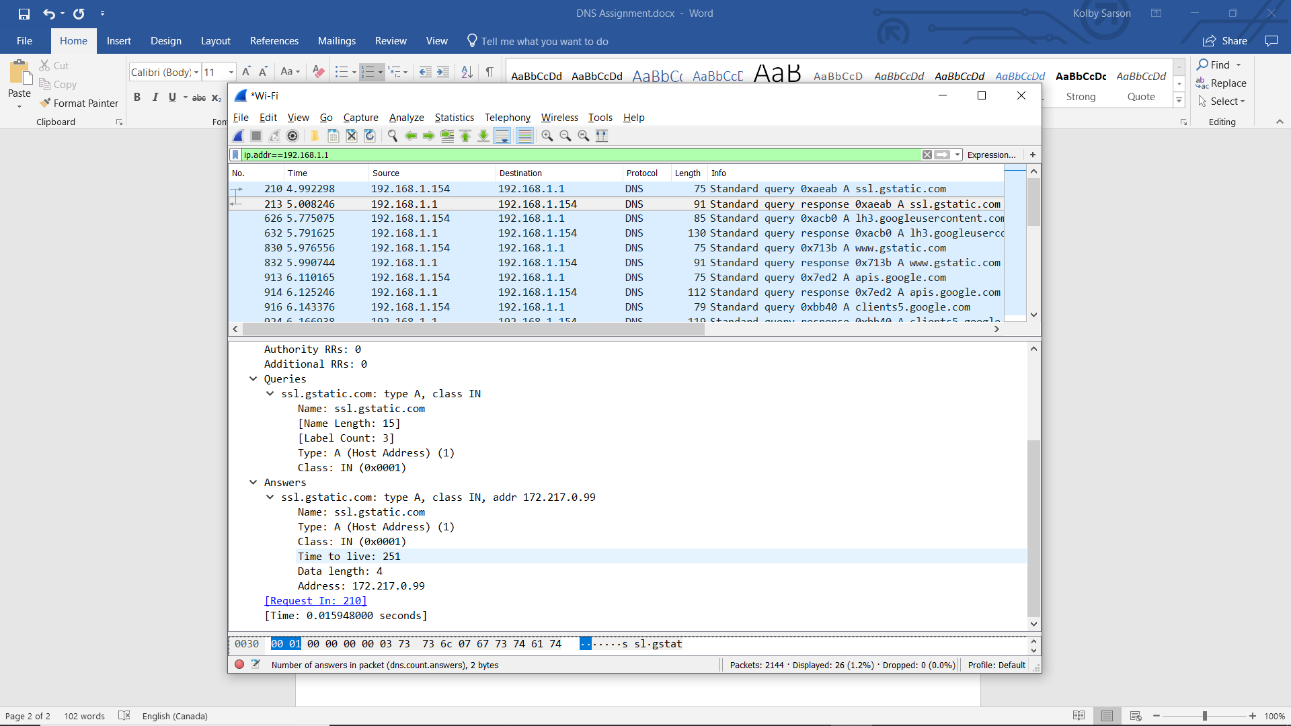There is one answer and it contains the following:
6. The first SYN packet was sent to 172.217.0.99, which corresponds to the IP of the answer acquired in the DNS response message.
7. No.

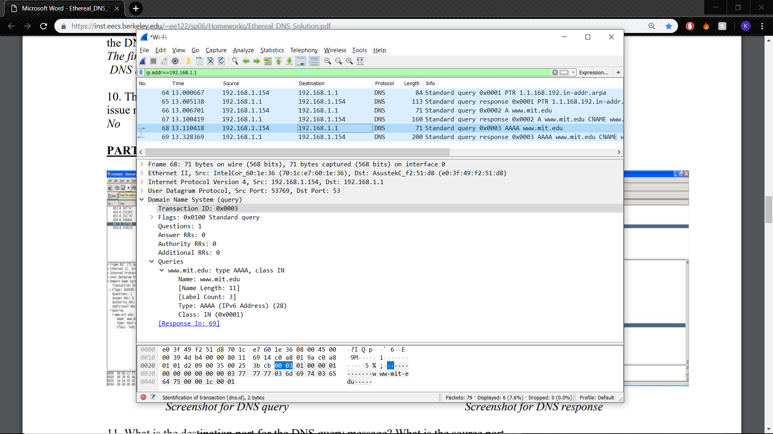**PART 3**

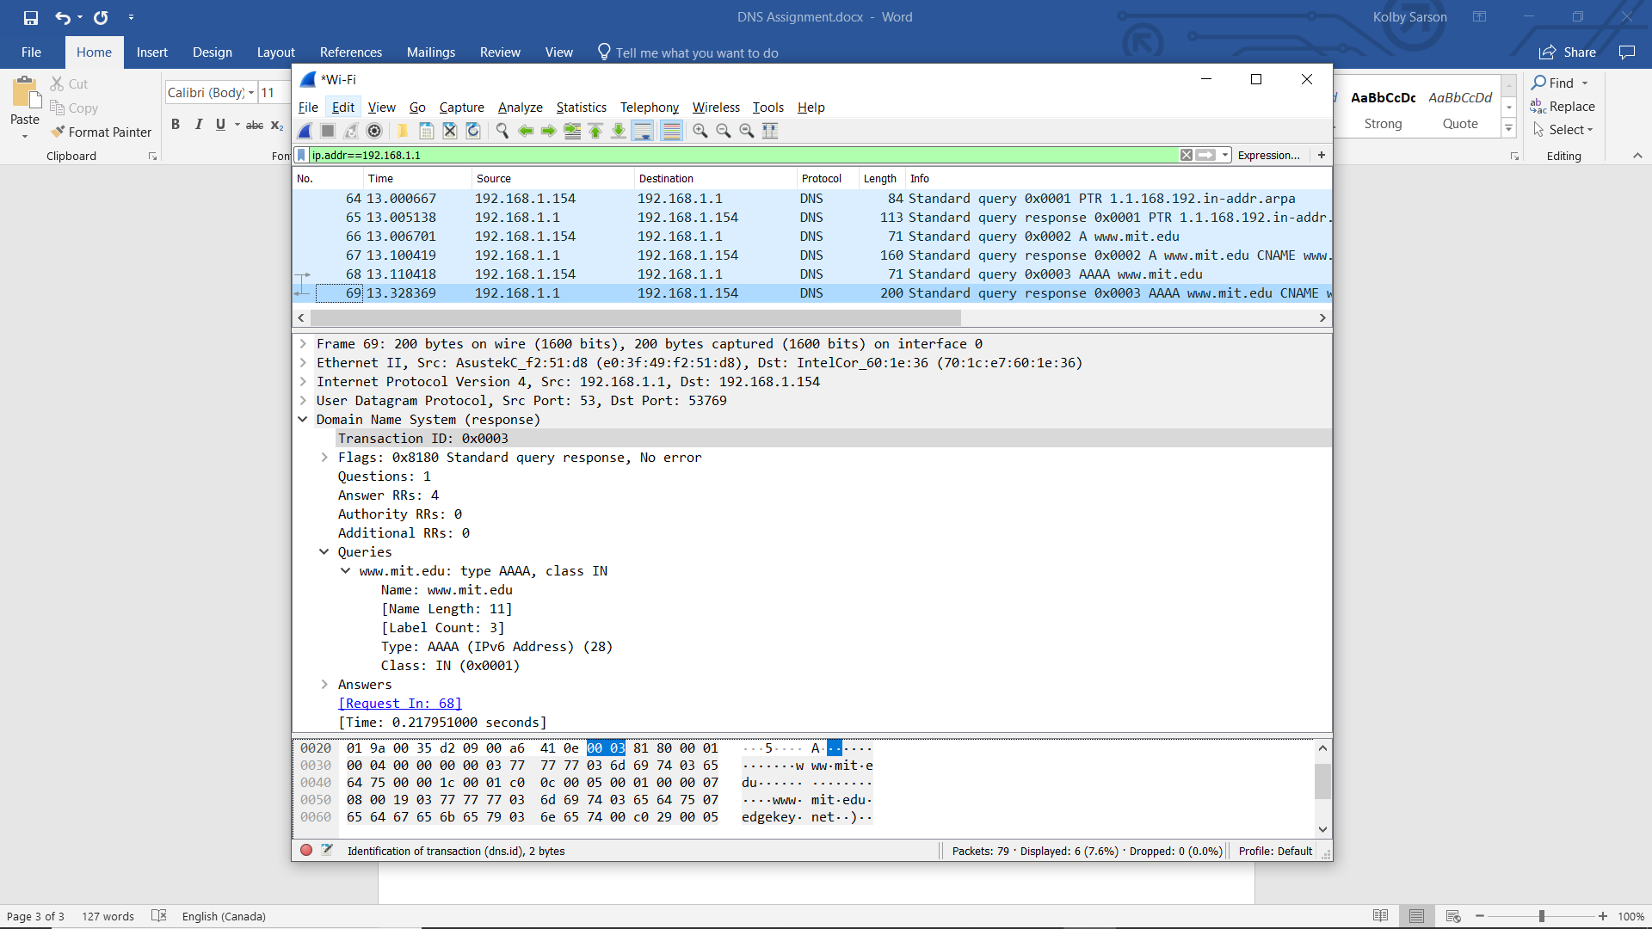

1. The destination port for the DNS query message is 53 and the source port of the DNS response message is 53.
2. It is sent to 192.168.1.1, which is the default gateway.
3. It is type AAAA and it does not contain any answers.
4. The response contains 4 answers, containing the following:

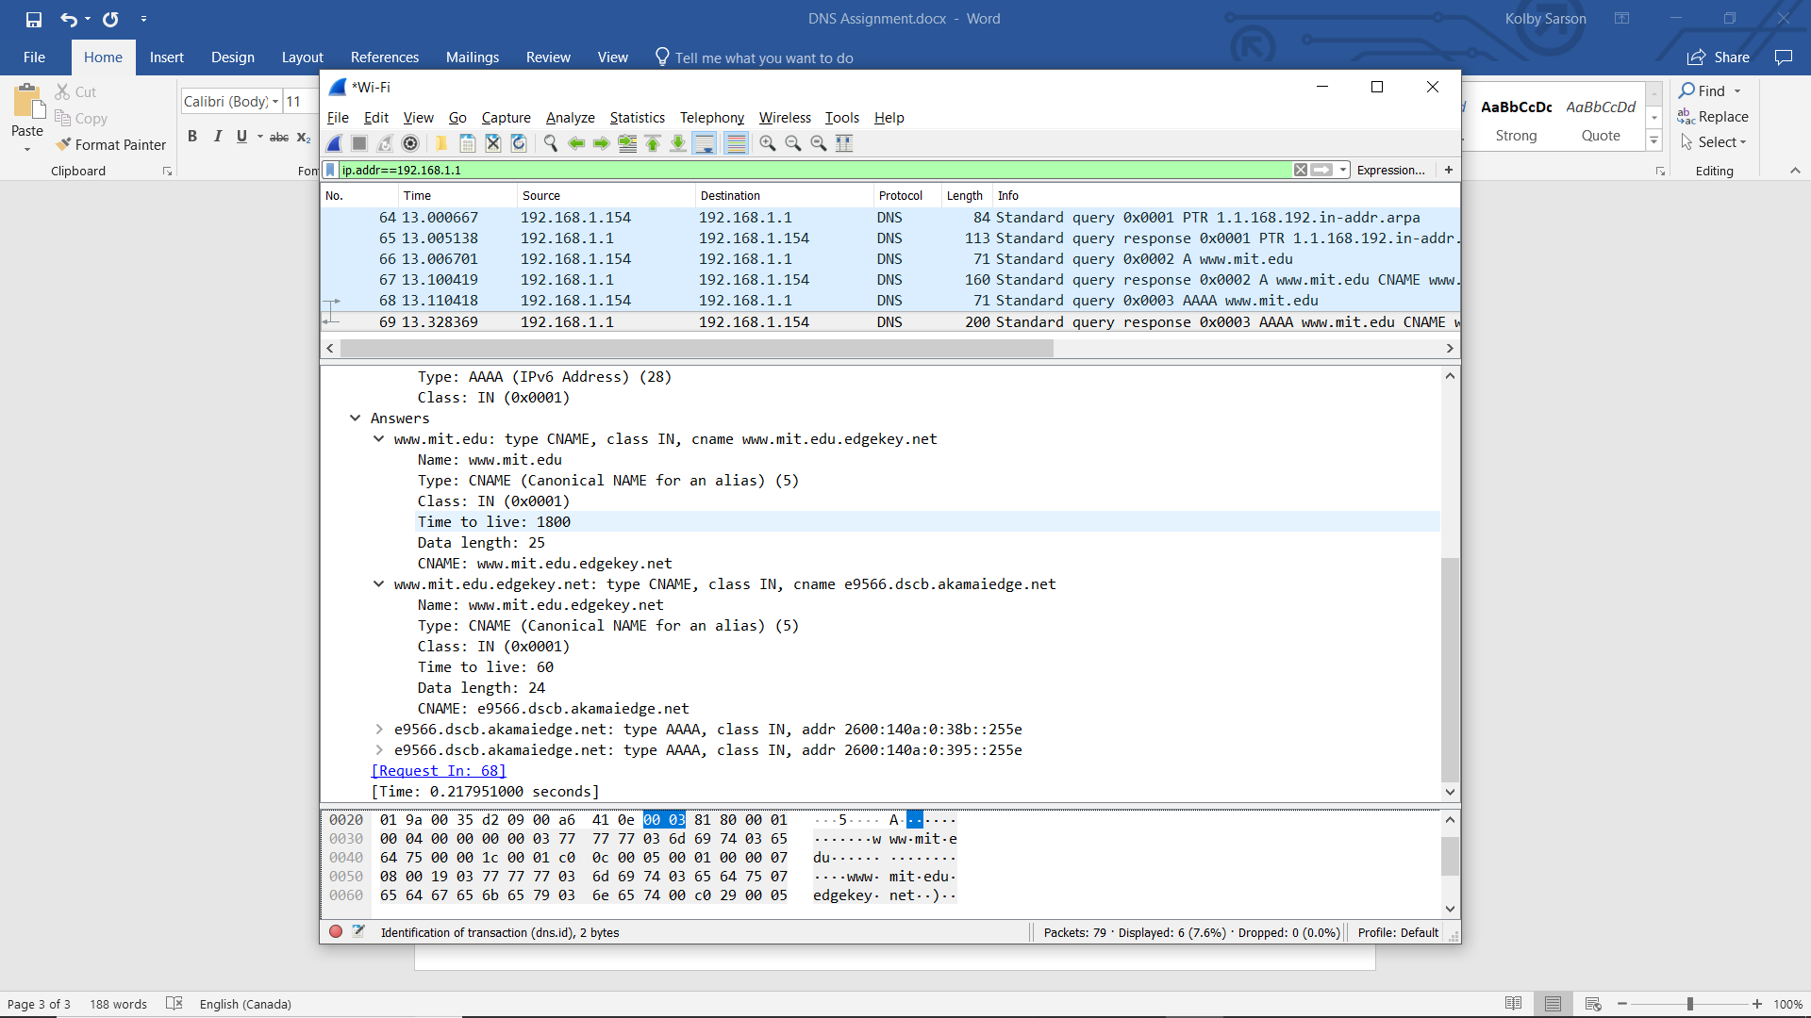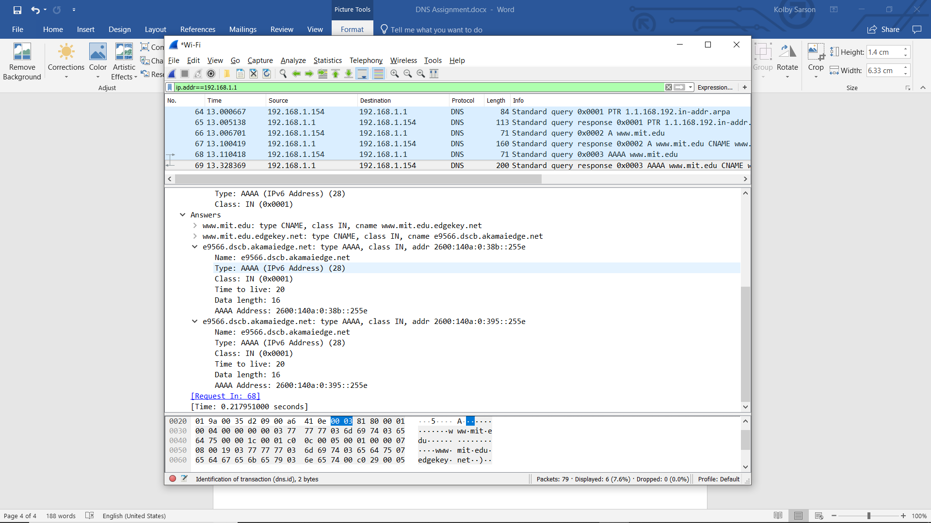

1. Screenshots provided throughout.

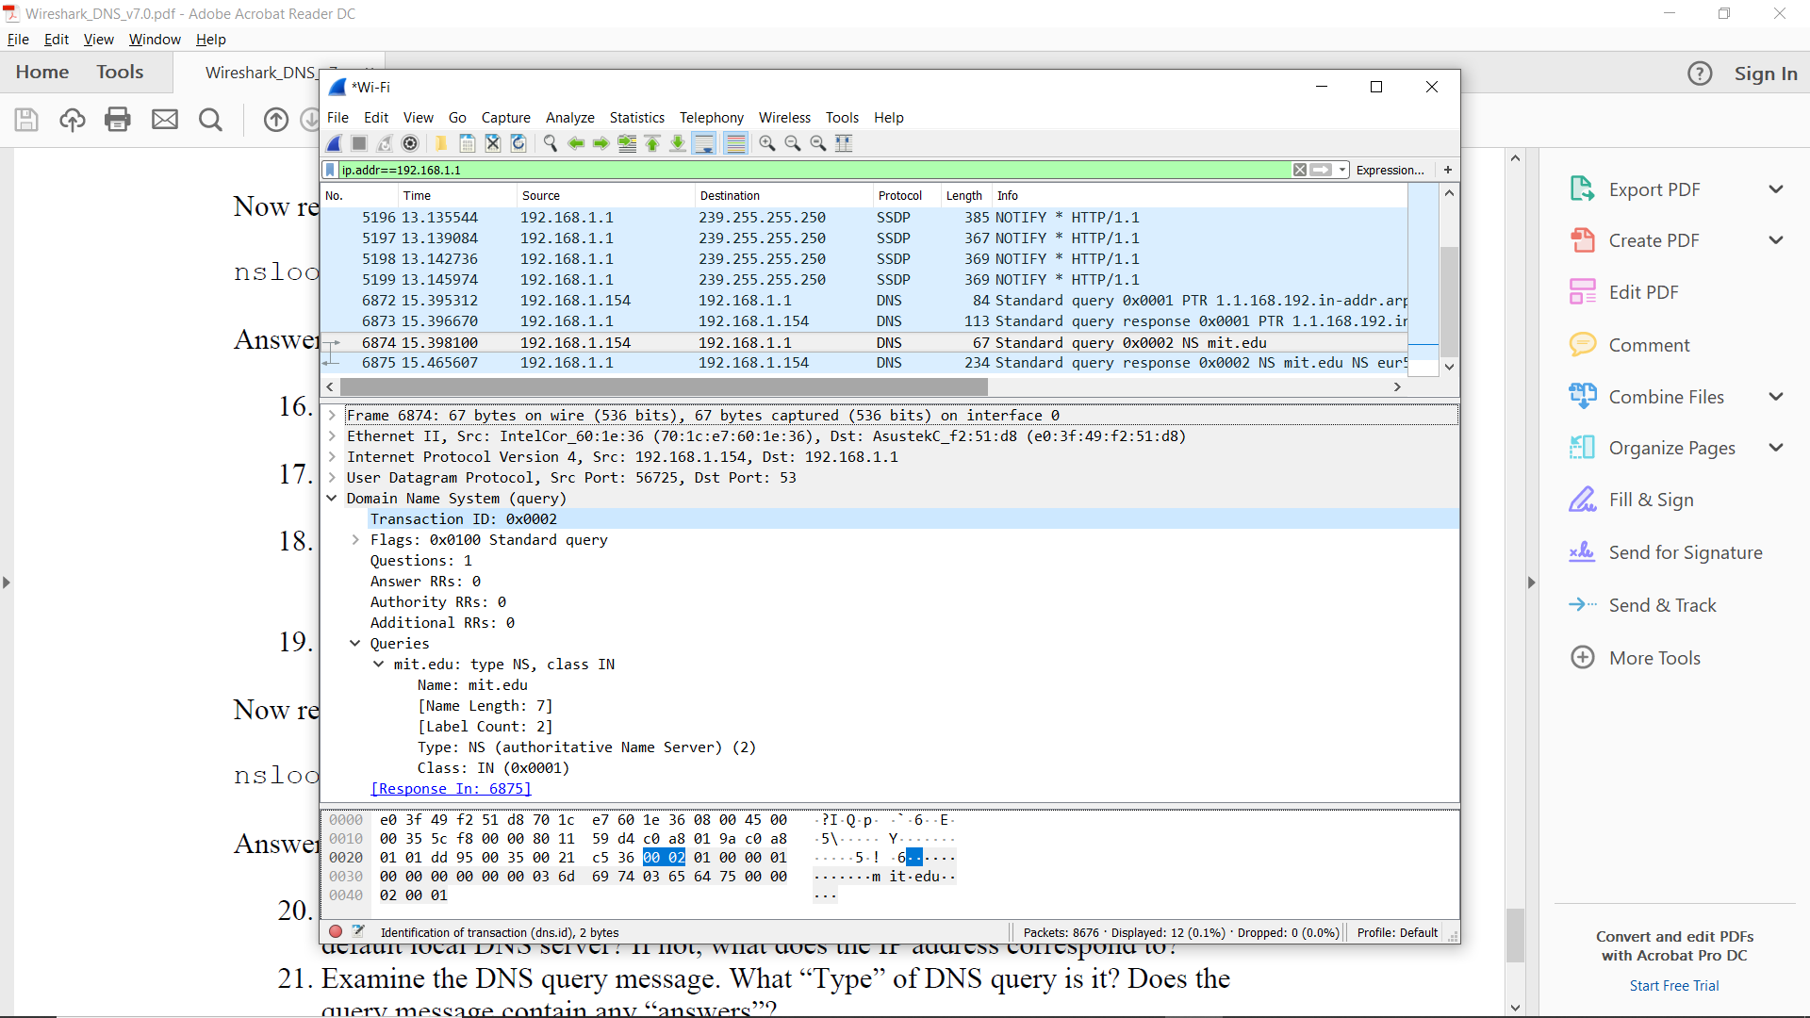**PART 4**

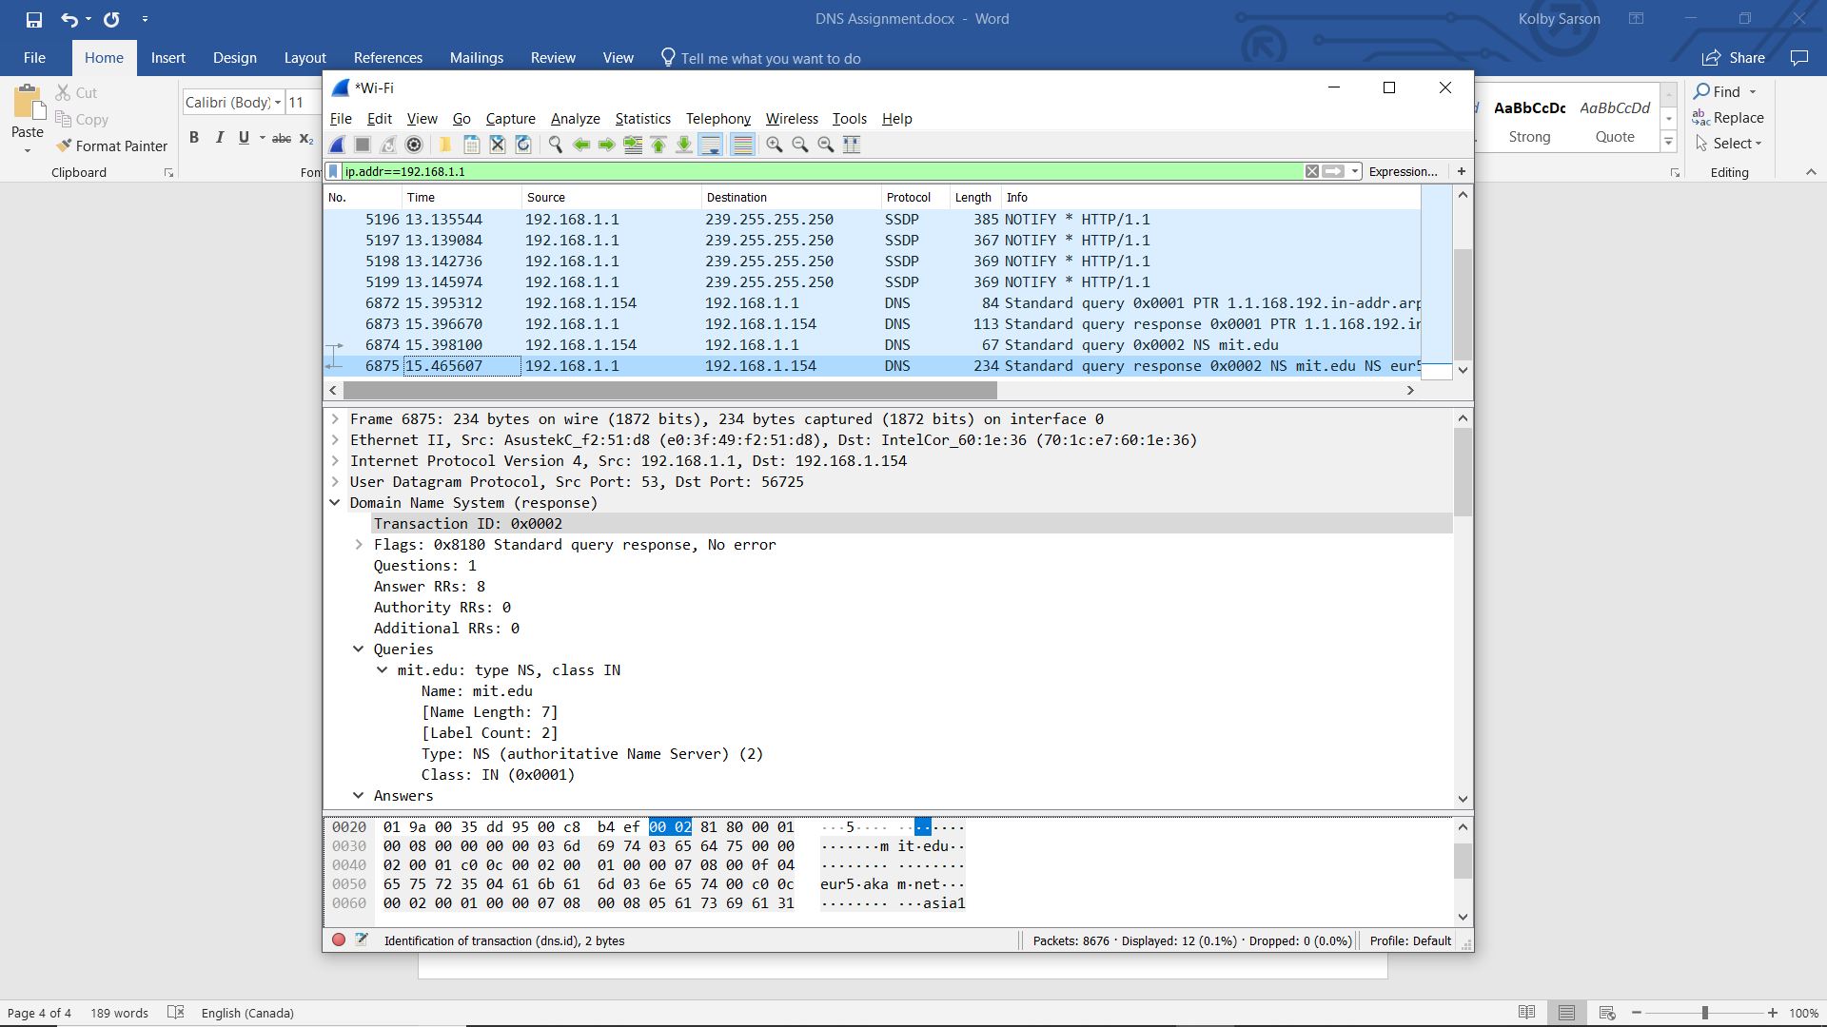

1. The destination IP for the DNS query message is 192.168.1.1 and this is my default DNS server.
2. It is type NS and it does not contain any answers.
3. 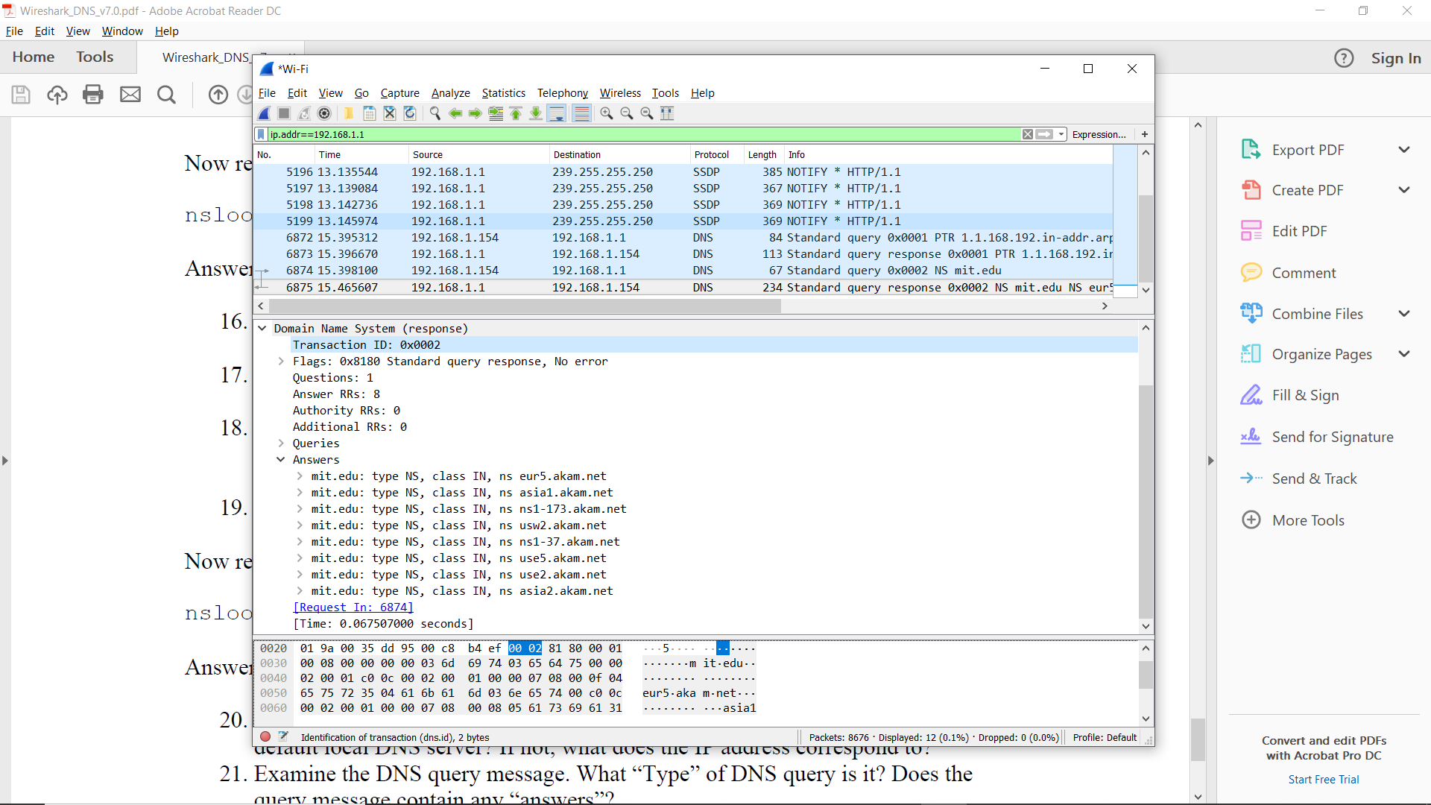The MIT nameservers are as follows:

They do not include the IP addresses

1. Screenshots provided throughout.

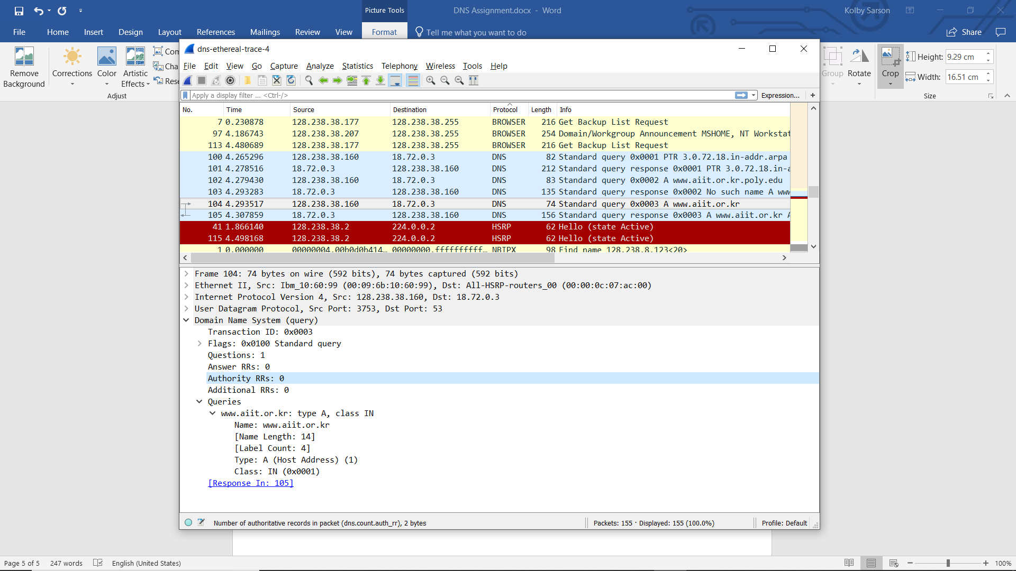**PART 5**

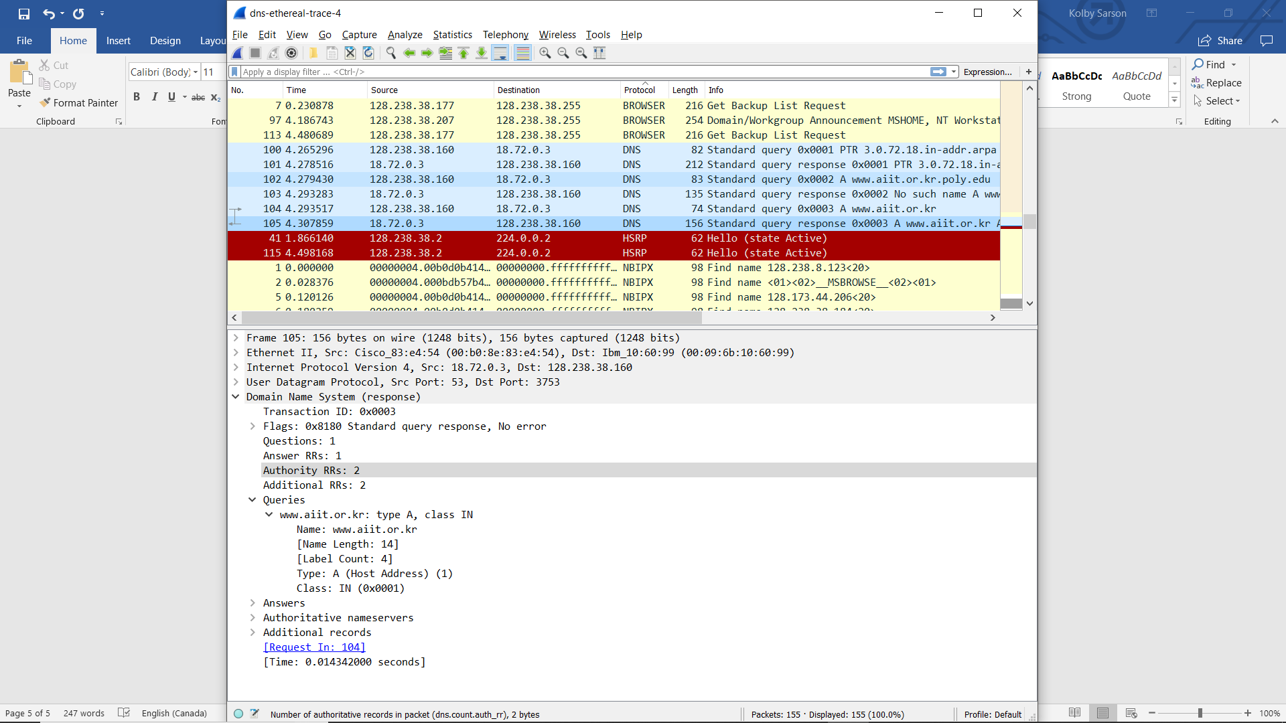

1. The query is sent to 18.72.0.3, which is bitsy.mit.edu.
2. The query is type A and does not contain any answers.
3. 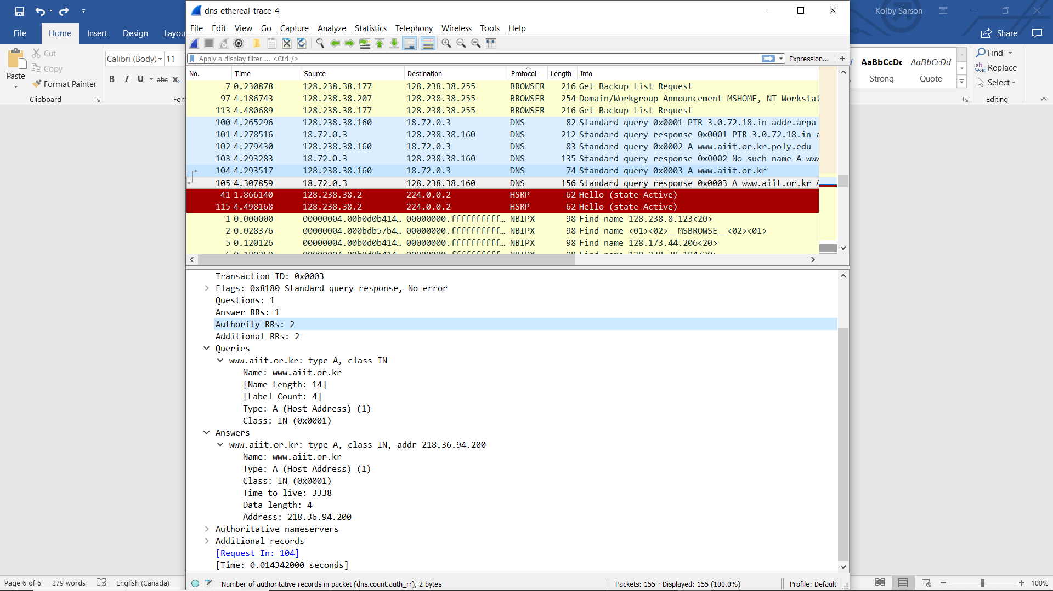There is one answer and it contains the following:
4. Screenshots provided throughout.